- UNDERSTANDING THE BASICS OF THE OS(SKILL)
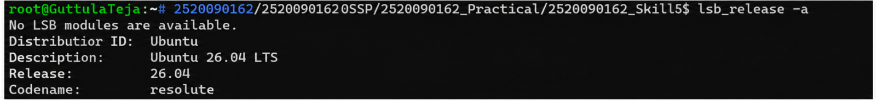

2.)
CREATING A
Program
